Mobile Data Collection Manual
for data collectors

Global Early Adolescent Study
Phase 2
Kinshasa
Version May 1, 2017

Contents
1. Introduction 4
2. Your role in the GEAS as a data collector 5
3. Best practices for using an Android device 6
a. Navigation 6
b. Connecting to the Internet 8
c. Saving battery life 9
4. Going into the field 11
a. Informed consent 11
b. Completing the tracking form 11
c. Completing the ID card 13
5. Using SurveyCTO Collect 13
a. Accessing the app 14
b. Get Blank Form 14
c. Fill Blank Form 15
d. Edit Saved Form 19
e. Send Finalized Form 21
6. Types of interviews you may conduct 23
a. Computer-assisted personal interview (CAPI) AKA face-to-face interview 23
b. Computer-assisted self-interview (CASI) 23
c. Audio Computer-Assisted Self-Interview (ACASI) 23
7. Ensuring data quality 25
a. Conducting shadow interviews 25
b. Call-backs and resurveys 25
c. Good documentation 25
8. Communication with data manager, field coordinator, and/or data collection supervisor 25
a. Routine check-ins 25
b. Maintaining progress reports 26
d. Special situations 26
i. If the ID number needs to be entered manually 26
ii. Reports of child abuse/neglect & participant distress 26
iii. In the event of an emergency 27
9. Send-off 27

Introduction

W
elcome to the Global Early Adolescent Study (GEAS). We are excited to have you on our team!
The GEAS is a multi-country study exploring the factors in early adolescence that promote healthy sexuality and, conversely, predispose youth to sexual health risks. In some sites, including yours, the study also serves as an impact evaluation tool to measure the effectiveness of an intervention. Your role as data collector is vitally important to the success of the study. We hope that this manual is helpful to you, but it is far from your sole resource. Should you have any questions that this manual does not answer for you, please contact your data manager or field coordinator.
Site data manager:
Email:
Phone:

Field coordinator: Eric Mafuta
Email:
Phone:
As you read through the manual, please note that the three main issues involved are 1) safety, 2) data quality, and 3) documentation. This means that your first priority is to ensure your own safety when in the field, and also to monitor the comfort of participants taking the survey. Data quality is extremely important, and will be tackled throughout the manual. Finally, documentation is a habit that you must get into early.
This manual is a primer on using the mobile data collection platform. It does not cover the equally important intricacies of the actual interviewing—you will be trained on that separately. We hope that this manual helps you get started with the mobile platform, and will be a handy reference once you are in the field.

Wishing you a fulfilling experience,
The GEAS Hopkins Coordinating Center

Your role in the GEAS as a data collector
As a data collector, you are on the front line of the GEAS and will experience the joys and sorrows of working directly with young adolescents and their parents in this important research.

We expect that as a data collector you will:
- Attend and actively participate in all training
- Adhere to research ethics and standards
- Collect quality data in a timely manner
- Complete accurate progress reports
- Communicate with your site DM on a weekly basis
Your data manager will continuously analyze collected data to ensure quality. In the event that he or she sees something unusual in the data, he or she will reach out to you to better understand what happened and how to improve. This is why documentation (writing down what happened) is crucial. You’ll be collecting a lot of data—and it’s easy to forget something if you don’t write it down.
The rest of this manual will help you understand how to collect great data. Let’s get started!

Best practices for using an Android device
Android is an operating system that many mobile devices run on. While there are several versions of Android, they are similar. Take some time getting familiar with the devices you will use to collect data. Here are some illustrations and tips to help you.

Navigation
All devices turn on and off a little differently. If you’re not sure how yours turns on, look for a button on the side or top to press and hold until the screen lights up. If you cannot find it, please check the user’s manual.
Once you have turned on your device, you will be asked to enter a passcode. Your data manager will provide this. It is important that you do not lose or share this passcode, as it is designed to keep participants’ data safe.
After you enter the passcode, you will see the main (“home”) screen:
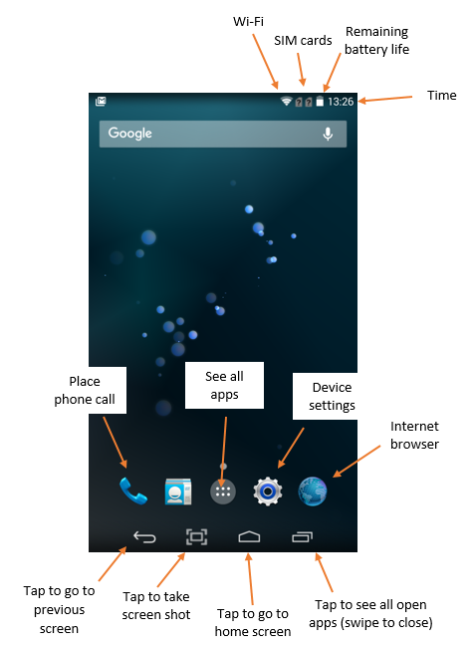

Connecting to the Internet
One of the first things you’ll want to do is connect to Wi-Fi or a SIM card. To do this, touch the “Device settings” icon, which will bring up a screen like this. Tap the “slider” to turn the Wi-Fi on and off. After tapping the slider to “on,” you will see a list of networks. Select the one you want. If you get lost while navigating, remember you can always tap the back button on the lower left of the screen to go back one step, or the home button to go to the home screen.
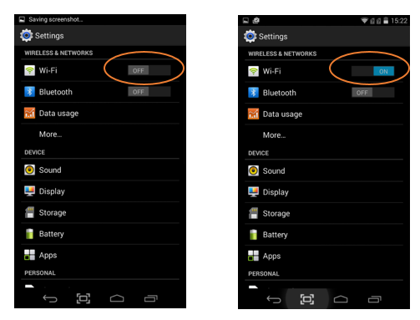
Note: If you have turned Wi-Fi on but it doesn’t seem to be working, open the Internet browser. It may take you to a website where you can authenticate your Wi-Fi sign-in. If this doesn’t work, check that the time and data are correct on the tablet, and if not update them to the current date and time. When tablets are unused for a while, the date and time may fall behind and prevent the device from connecting to the internet.

Saving battery life
Saving battery life is very important! The two main things that use up battery life are screen brightness and Wi-Fi. Fortunately, when you are in the field, you will only need Wi-Fi to download a new survey version (which will be very infrequent), to send finalized forms, and to place a call to your data manager, if necessary.
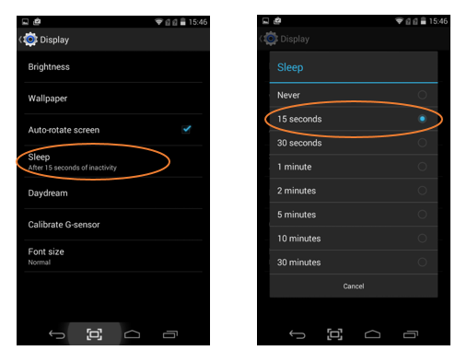
There are three things you can do to save battery life.
First, turn the screen off when you are not using the device, and set the “Sleep” setting to have the screen automatically run off after a short interval of inactivity. To do this:
- Tap the “Device settings” icon
- Tap “Display” (see image above)
- Tap “Sleep”
- Select the shortest time interval

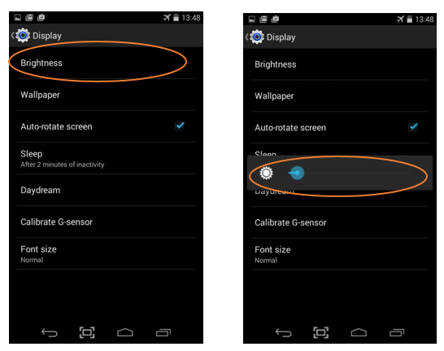

Next, set the brightness of the device to be as dim as possible (yet still visible). To do this:
- Tap the “Device settings” icon
- Tap “Display”
- Tap “Brightness”
- Drag the bar left to dim the screen

Finally, when you are not using the Internet, put the device in “airplane mode.” The device should always be in airplane mode when conducting surveys. To do this:
- Tap the “Device settings” icon
- Tap “More…”
- Tap the checkbox next to “Airplane mode”
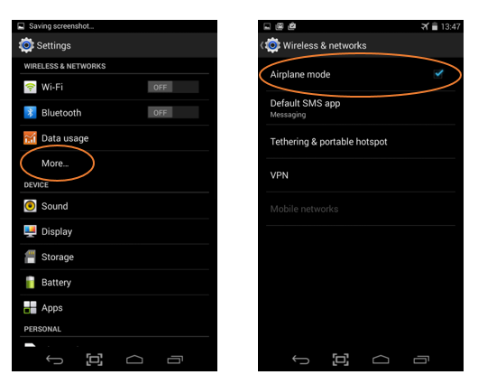
Airplane mode ensures that the Internet is off and power is saved.

Blocking apps
If the participants will be handling the tablets at any time, it is good practice to install a piece of app-blocking software to prevent them from playing games or with the camera. If your DM has installed this, he or she will tell you the passcode needed to access other apps you may need (such as settings, the phone, or the browser).
WHAT DAY IS IT?
Before you administer a survey, remember to CHECK THE DATE on the tablet!
Sometimes, if a tablet is shut down incorrectly or the battery is removed, the date may reset and need to be manually corrected! You can do this in Settings.

Going into the field
You will be conducting two types of surveys at baseline, one with parents/guardians and one with adolescent participants. The parent questionnaire will be completed when obtaining parental consent using computer-assisted personal interview (CAPI) (see Section 6 for details). The parent questionnaire is designed to take about 15 minutes, and the parents ID number is the same as the adolescent participant ID number.
Before we dive into the details of using the SurveyCTO Collect app, there are some basic recordkeeping issues to learn, first.

Informed consent
On the tablet you will have a space in which to indicate whether the participant (parent AND/OR adolescent) has given informed consent to participate.
You will go through a detailed consent form with each parent and adolescent participant (with adolescents it is called, “assent”), answer any questions they may have, and ask them to sign one copy of the form if they agree to participate. Whether the parent or adolescent participant has agreed to participate is one of the first questions you will be asked on the tablet when starting a new survey. Please indicate that the participant understands and has agreed to take part in the study by selecting “Yes,” but also complete a new form for potential participants (parents and adolescents you tried to recruit into the study) whom said that they did not wish to participate (select, “No”). This will allow us to see what percentage of people we invited to join the study decided they wanted to participate. After you select, “No,” the survey will end.

Completing the tracking form
The tracking form is to be completed by hand at the time when parental consent is obtained, concurrently with the adolescent participant ID card (Section 4c) and is to be securely stored in a locked cabinet with participants’ signed parental consent and adolescent assent forms. The tracking form will be used by the FC and DM to track and follow-up with participants over time. Make sure you carefully complete the tracking form. You may not be able to fill it in completely, but try your best and make additional notes, if needed.
Information to be entered onto the tracking form:
- Participant ID number
  - You will find this number on the ID card assigned to the adolescent participant.
  - The participant ID number will start with ‘I’ or ‘C’ based on whether the participant is in the intervention or control group.
  - Parent/guardian participants have the same ID number as their adolescent child participant.
- Adolescent participant name
- Adolescent participant sex
- Adolescent participant date of birth
- Whether the adolescent participant is in-school or out-of-school
- School where the participant will report for data collection (for in-school participants, only)
- Name of the individual who first identified the participant for the study (for out-of-school participants, primarily)
- Adolescent participant home neighborhood
- Adolescent participant phone number
- Parent/guardian name and phone number
- Other contact phone number (i.e., another family member or a neighbor)
- Participant address or a landmark near home
- Dates of the each wave of the data collection
- Observations at each point of data collection

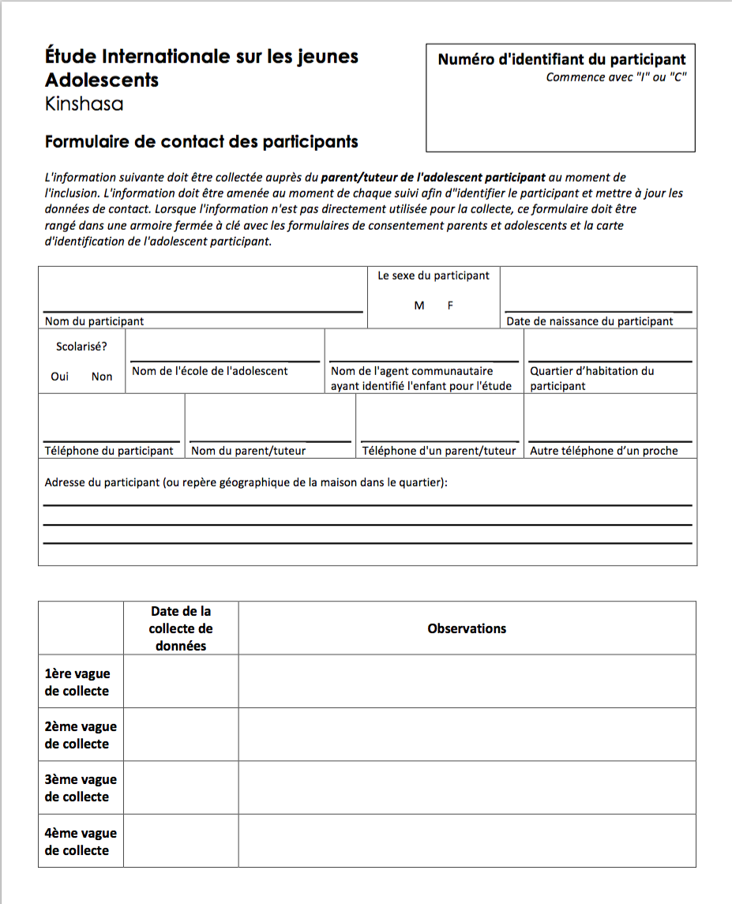

Completing the ID card
Using ID cards helps us ensure that the correct participant ID number is entered into the survey form at each wave of data collection and also helps you make sure you are interviewing the participant you expect to be interviewing. At baseline data collection you will complete two copies of each ID card—one for the participant to keep and bring back at each wave of data collection and one to store with the tracking form and bring to subsequent waves of data collection. Make sure you ask the adolescent participant to keep his or her ID card safely at home and to bring it back for each wave of data collection. Note that while there is identifying information on the ID card, it is not linked to the participants’ survey data except via the ID number.
The ID card contains the following information:
- QR code with ID number
  - Write this ID number on the participant’s tracking form.
  - Participants in the intervention group will have an ID number starting with an ‘I,’ and participants in the control group will have an ID number starting with a ‘C.’
  - Parents/guardians who complete the parent questionnaire will have the same ID number as their adolescent child participant.
- Adolescent participant name
- Adolescent participant date of birth
- Adolescent participant sex
- Parent/guardian name and phone number
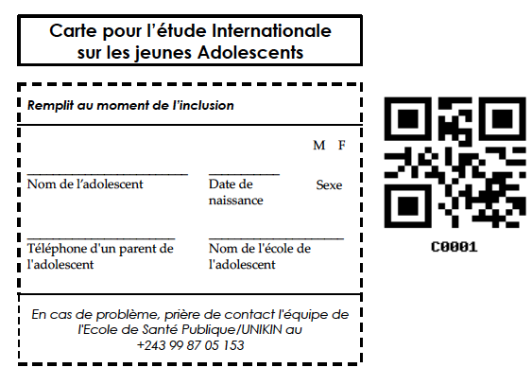
- Contact information for returning lost cards
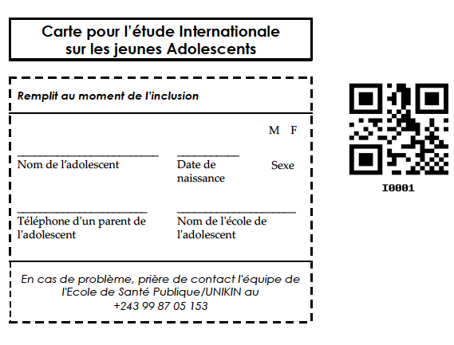

Intervention group ID card Control group ID card

Using SurveyCTO Collect
The GEAS is a big study with a small team, so we are using a company called SurveyCTO to help us collect, secure, and manage data. One part of SurveyCTO is a mobile app called “Collect,” which you will use to administer surveys to participants.

Accessing the app
If you don’t see the SurveyCTO Collect icon on your home screen, tap the center button to bring up a list of all apps on your device, and swipe until you see it. Then, open the app by tapping it once.
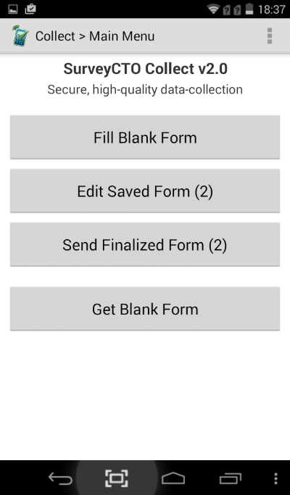
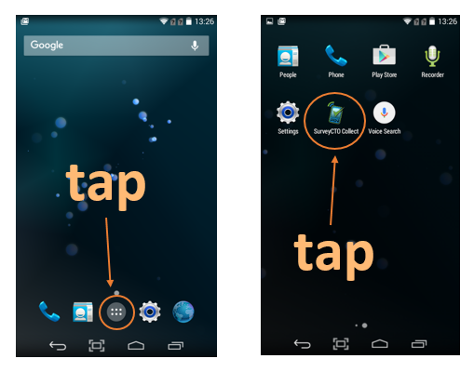
You are now ready to use SurveyCTO Collect!
Let’s take a look at the main screen. As you can see, there are four buttons that you will be working with. Most often you’ll be using “Fill Blank Form” and “Send Finalized Form.” Occasionally, you may have to “Edit [a] Saved Form.” In order to fill a blank form (that is, get a clean/new survey for a new participant), you first need to get that form from onto the device. Your DM may already have done this. Occasionally s/he might make some changes to the form, and ask you to “get” the new one. This is when you will need to “Get Blank Form.” Make sure you have done this before going into the field to collect data!

Get Blank Form
At the very beginning of data collection, or when your DM adds a new version of the form, you will need to tap “Get Blank Form” to get a new form on your device. Let’s try it together now. First, make sure you are connected to the Internet. Then tap, “Get Blank Form,” and see what happens.
You might have to authenticate first, to get a blank form. This is a security precaution. Enter your data collector username and password (provided by your DM).
Below is what I see when I tap “Get Blank Form”—some practice and draft surveys that the lead data manager here at HCC has uploaded. You will see different forms, and your DM will tell you which form or form(s) to “get.”
To get the form onto your device, so that you can use it, simply tap the checkbox next to its name, then tap the back button to go back to the main SurveyCTO Collect screen.
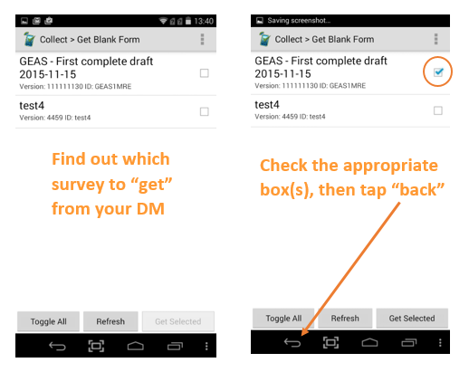
The form is now on your device and ready to be given to participants! Nice work!

Fill Blank Form
After you “get” the right form onto your device and you are ready to administer the survey to a participant, you need to use the “Fill Blank Form” button. This is easy, and you’ll get really good at it because you’re going to be doing it a lot.
You do not need Internet to fill a blank form that is already on your device. In fact, at this point your device should be in airplane mode.
Make sure you are on the main SurveyCTO Collect screen (the one with the four buttons) and tap “Fill Blank Form.” You will see a list of all forms that you have “gotten.” Here’s what I see when I tap “Fill Blank Form”:

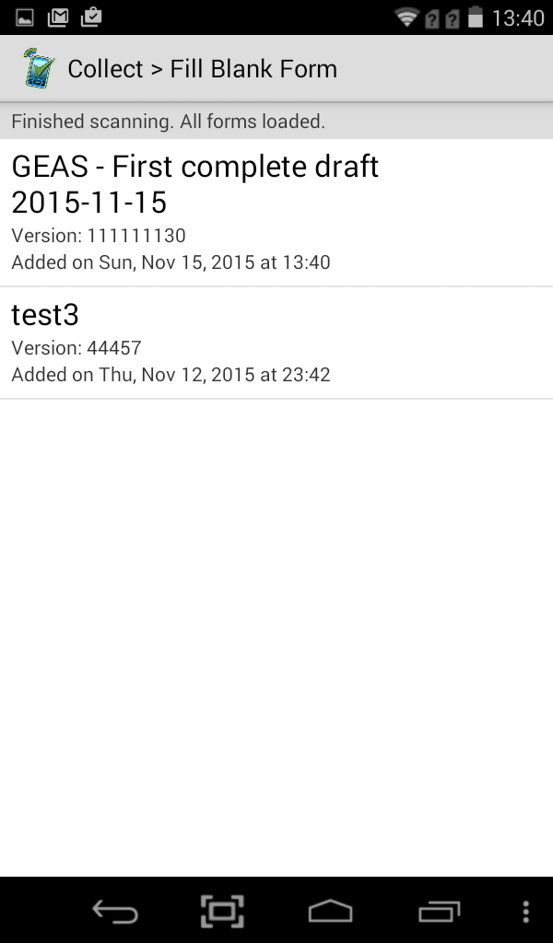
The one at the top is the one I most recently added. Let’s pretend that this is the form (survey) that I want to administer to a participant. To do that, all I need to do is tap it!
Tap a form on your device and see what happens.

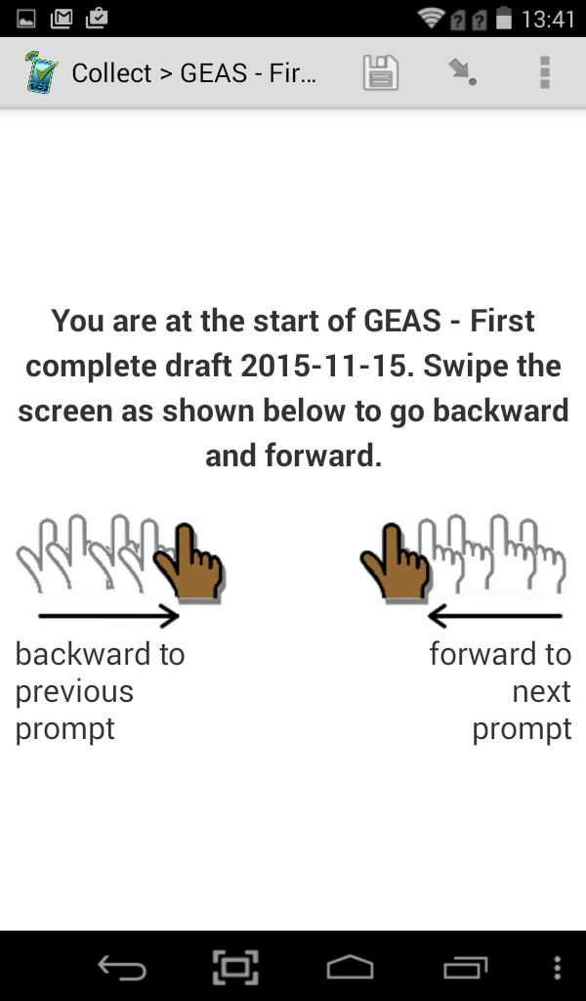
Do you see what I see? A bunch of fingers swiping back and forth? If so, great! You’re at the start of a new form! Follow the directions and swipe forward to see the next screen.
SurveyCTO Collect surveys requires a lot of swiping. You and/or participants will need to swipe forward to go to each new question, and back to see previous questions, if they need to check or change an answer.

Indicate whether participant has consented/assented to participate
On the tablet this is a simple “Yes,” or “No” question, but reflects a fairly in-depth discussion you had with each prospective parent and adolescent participant. Please indicate on the tablet whether the parent and/or adolescent participant has agreed to participate in the study.
Scan the QR code
You have a paper copy of the ID card which needs to be completed during Phase 2 (baseline) by hand. As part of the ID card, there is a QR code that needs to be scanned in order to link participants’ records over time. The only data in the QR code is the participant ID number. When prompted, scan the QR code using the barcode scanner app preloaded on your tablet. The barcode scanner will enter the ID number on in the QR code and on paper into the ID number field. Please make sure the number on the ID card matches the one scanned into the survey form.
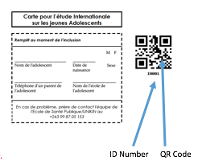
If the participant has forgotten their ID card during the follow-up waves of data collection, verify the identity of the participant based on the tracking form. Then, scan the spare ID card on file using the barcode scanner. Give the spare ID card to the participant to keep and bring to the next wave of data collection. Make a note on the tracking form that the participant’s ID card was lost and replaced, and alert your data manager and/or field coordinator, who will have a new spare card made for that participant.
In the event that the spare ID card is not available, the QR codes are damaged, or the tablet’s QR code scanner is not working, verify the identity of the participant based on the tracking form and then call the field coordinator or data manager over to help you. The FC or DM will give you permission to enter the ID number manually with great care based on the tracking form, and double check that it is correct.
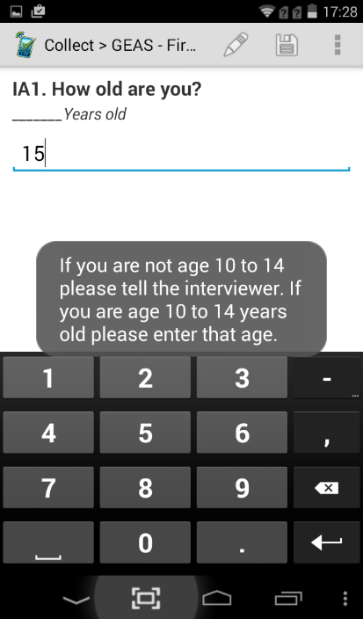
Error messages & comments
Sometimes you (or the adolescent participant) may see an error message pop up on the screen. These can appear for a number of reasons, the most common being:
Tap to add a comment
- A required question was not answered
  - Participants are allowed to refuse any question, but questions must be marked “refused” and cannot be skipped.
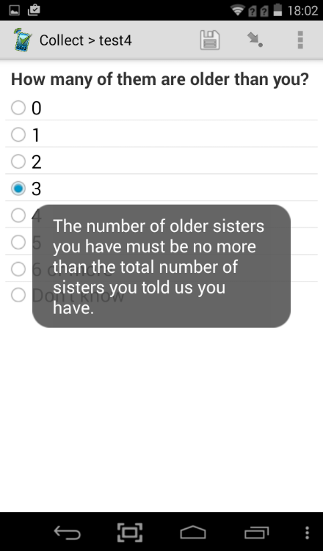
- A number entered is out of range (for example, if the participant enters age 9, they will get an error message, because they are too young to be in the study, or if you accidentally type a very large number (say, that they live in a house with 555 rooms, instead of 5 rooms), the error will ask you to check the accuracy).
  - If you encounter a problem with this (say, you have a participant that really does live in a 555 room house, enter the highest number allowed, document the problem, and alert your DM after finishing the survey.
    - Please document the problem on paper AND by making a comment in the app (click the pencil icon near the top to create and save a comment). Notes added in the app are associated with the question in which you add them.
- An answer contradicts an earlier answer (example, the participant has said she has two sisters, then later that she has three older sisters)
  - Go back and revise the earlier answer to the correct answer, or, answer the current question correctly (depending on which is correct).

Go To Prompt
With your help the survey has become much shorter, but it is still long. Sometimes, like if you (or a participant) made a mistake and need to go back to correct it, you might need to skip around the survey. Swiping back can take a long time if it happened much earlier. SurveyCTO Collect has a feature called “Go To Prompt” that allows you to see all of the questions, scroll through them, and select the one you want to go to.
To access this feature, tap the three vertical dots in the upper right-hand corner of the screen. This will bring up a menu. Tap… you guessed it, “Go To Prompt.”
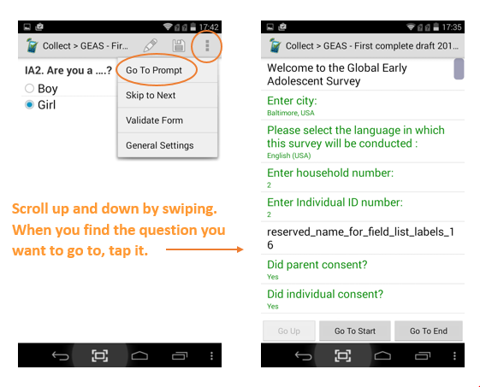
That’s all there is to it. When you and/or the participant reach the end of the survey, you are ready to “Finalize.” But first…

Edit Saved Form
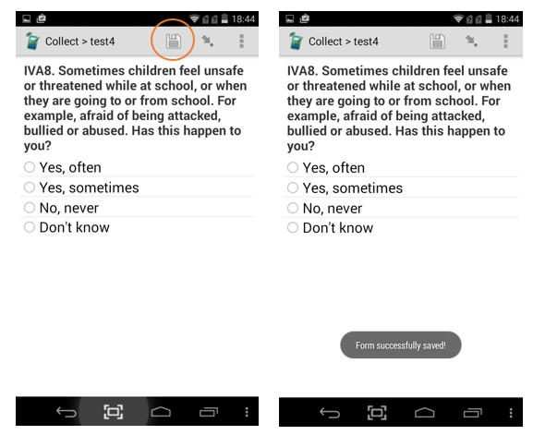
Things don’t always go as planned. If something unforeseen happens while you are giving an interview or while a participant is taking the survey and you need to pause, don’t worry—you can save the data that’s been collected, and save the form so you can come back and finish it another time. To save a form, tap the “save” icon at the top of the screen.
To exit the survey while in the middle of it, just tap the back button. It’s okay if you forgot to save it first, the app will ask you again.
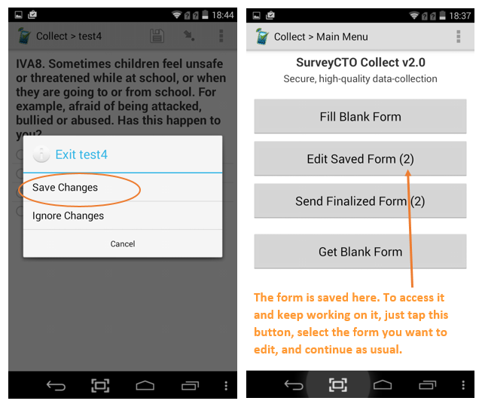
See? All I did was tap the “back” button in the middle of taking the survey, and it asked me whether I wanted to save changes or ignore them (I tapped “Save Changes”). When I’m ready to complete the interview, I just have to tap “Edit Saved Form,” select the one I want, and fill, and finalize as usual.
Speaking of finalizing…

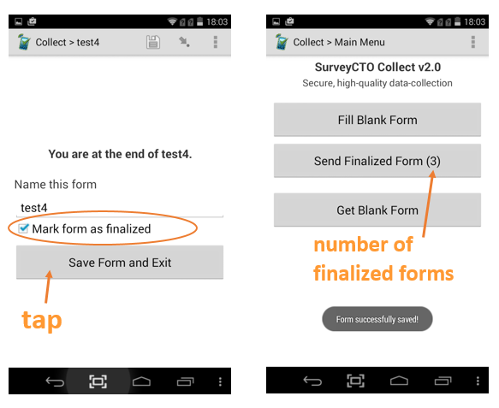
Send Finalized Form

To send a finalized form, you first need to finalize it. When you and the participant reach the end of the survey, you’ll see a screen a lot like this. All you need to do is make sure the checkbox is checked, and tap “Save and Exit Form.”

And now, the last step: sending finalized forms. You’ll need an Internet connection to send finalized forms, so ask your DM or FC when you should upload finalized forms.
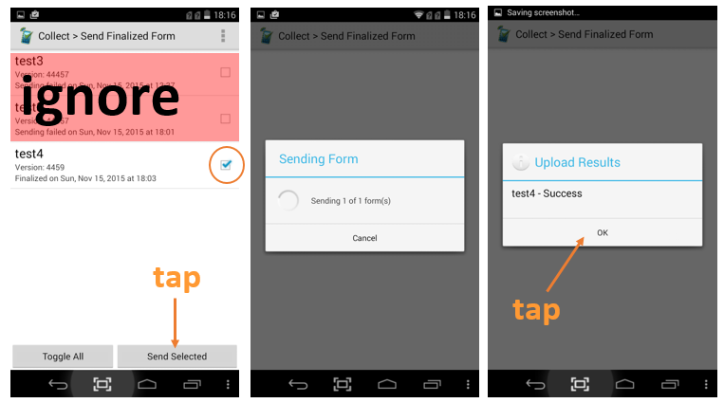
To send finalized forms, simply tap the “Send Finalized Form” button, check the box next to the form(s) you wish to send (or tap “Toggle All” to select all of them), and then tap “Send Selected.”

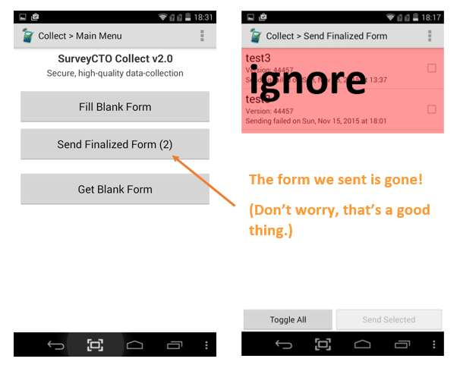

As you can see, where it used to say “(3)” it now says, “(2).” Our form is gone, and that’s a good thing! It’s on its way to your data manager, who will check to make sure the data make sense, and then it will be analyzed to help us understand how gender norms impact young adolescents’ health and well-being. Sweet!

Types of interviews you may conduct
The GEAS is now in the second phase, which means we’re now collecting longitudinal data to understand how gender norms and other factors impact healthy adolescent development. There are three ways you may be asked to administer the survey: face-to-face interview (AKA computer-assisted personal interview (CAPI)), computer-assisted self-interview (CASI), and audio computer-assisted self-interview (ACASI). The process of filling the form is the same for each, the difference is whether you will work directly with the participant, or the participant will work alone on the tablet. Your DM, FC, and PI will train you on the nuances of being a good interviewer.
You will interview adolescent participants using CAPI for the majority of the survey. Questions about adverse childhood experiences (ACEs) and the sexual behavior module will be administered by CASI or ACASI (as the adolescent prefers). You will interview parents using CAPI.

Computer-assisted personal interview (CAPI) AKA face-to-face interview
Computer-assisted personal interview (CAPI) is when you, the data collector, sit with one participant and you work through the survey together.
When conducting a CAPI survey, most often you will hold the tablet, read the questions (and answer choices, when necessary) aloud to the participant, and enter the participant’s answers on the tablet yourself.

Computer-assisted self-interview (CASI)
When administering a survey using computer-assisted self-interview (CASI), the participant is expected to read each question and answer choice him-/herself. When using CASI, you can watch over multiple participants at one time, as they will be working individually, and be available to address any issues they may have. One benefit of CASI is that you can collect more data at one time, but it can be challenging for younger participants to read and work alone for an extended period.

Audio Computer-Assisted Self-Interview (ACASI)
Audio computer-assisted self-interview (ACASI) is a bit like a combination of CAPI and CASI. With ACASI, the participant holds the tablet him-/herself and therefore has complete privacy. The participant also has a set of headphones and can hear each question and answer choice read aloud. This reduces fatigue from reading and therefore the time the survey takes to complete, and allows data collectors to monitor multiple participants.
When you use ACASI, make sure that the participant has a pair of headphones. Audio for each item will begin immediately, and can be replayed by pressing a button on the screen that looks like a speaker. Make sure the participant understand that he or she can replay the question AND play/replay the answer choices by tapping these buttons.
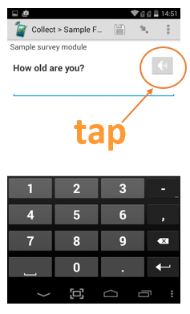
Use the devices volume control buttons to increase or decrease the volume, and make sure the participant knows how to adjust the volume, as well.

Ensuring data quality
Collecting quality data is the name of the game. Any data collector purposely falsifying data will be immediately dismissed. Now that that’s out of the way, what can you do to collect the best quality data? First, understand that “quality data” has little to do with what participants report in the survey—there are no “right” or “wrong” answers. It’s about accuracy and completeness, and there are a few things you can do to ensure that data is reported as accurately and completely as possible.

Conducting shadow interviews
During training, you will conduct a lot of practice interviews, with other data collectors and research staff, and with young adolescents. But what are shadow interviews?
From time to time, your data manager might attend your data collection sessions to learn about how you conduct interviews in the field. He or she will pay attention to see that you are following the protocol you were trained on, your manner of interviewing participants, and how you manage the SurveyCTO Collect app. Don’t be nervous—she’s there to help, and will let you know what you’re doing well and what you can improve on.

Call-backs and resurveys
Occasionally, researchers check data quality by going back to a participant who already completed the survey and administering another short survey (with questions similar to the actual survey) to see if they report the same information or not. Your data manager will let you know if and when to do this, and will provide the sample survey for you to administer.

Good documentation
We’ve said it before, but it can’t be overstated—good documentation is essential to ensuring quality data is collected. There are two main ways to document your observations and any issues that arise in the field.
First, there is a small amount of space on the tracking form for you to jot down key observations or issues you experienced at each wave of data collection and for each participant. If you need more space, go ahead and write on the back of the form or attach an additional sheet of paper.
Second, you can insert comments into the survey app by tapping the pencil icon near the top. This is primarily to be used when you need to explain something about a particular question. For example, the parent might say, during the parent questionnaire, that the family has a TV and sometimes it works and sometimes it doesn’t. The question asks to count only items in the home that work, so you will have to determine whether to count this or not. What would you choose? Do you think it counts? Ask your FC what they think to see if you are right! If something like this came up in the field it would be a good opportunity to insert a comment stating something like, “TV works sometimes.”

Communication with data manager, field coordinator, and/or data collection supervisor

Routine check-ins
We ask that you be in contact with your site DM, FC, and/or DC supervisor at least once per week during active data collection periods. The preferred method of contact is by phone. Yes, email and text messaging are sometimes easier and feel “faster,” but what you are doing is very important, and it’s important that you and the leadership staff have a conversation about your experience on a weekly basis. Please follow the check-in procedures your FC, DM, and DC supervisor have set up for you.

Maintaining progress reports
We ask that all data collectors maintain a progress report to be submitted to the DM on a regular basis, as determined by the site leadership team. Your DM and FC will determine the elements of this worksheet, but it’s important that you keep it up-to-date and include any observations that you’ve had and documented. Not only will this help you stay organized, it will help the DM understand patterns or outliers in the data as he or she analyzes it and performs data quality checks.

d. Special situations
In general, if you have a technical problem with the survey, the tablet, or the SurveyCTO Collect app while collecting data that you cannot solve, save the data, pause the interview (offer the participant a break for the restroom or a snack), and call your DC supervisor, DM, or FC. Be sure to document the problem and how you solved it using the tracking form
There are a few specific instances where you will need to reach out to your DC supervisor, DM, or FC while in the field. One of these, which we have already discussed in Sections 4c and 5c, is entering the ID number manually if/when the QR code cannot be scanned.
You will also need to reach out to your supervisor when a participant either a) discloses being subjected to child abuse or neglect or b) appears distressed due to the survey.
Last but certainly not least, we will describe our procedure for handling emergency situations.

If the ID number needs to be entered manually
If the QR code cannot be scanned for any of the reasons outlined above, you must alert your supervisor before manually entering it into the tablet. This is to ensure accuracy, the importance of which cannot be overstated. If this occurs, make a note that the ID number was entered manually and also alert your supervisor that new ID cards for that participant are needed.

Reports of child abuse/neglect & participant distress
There are two types of incidents that need to be documented and reported to your supervisor, a) reports or disclosures child abuse or neglect and b) distress precipitated by the survey questions.
Child abuse and neglect
While obtaining informed parental consent and adolescent assent it is important to emphasize that, while the adolescent participant’s responses are private and confidential, reports of child abuse or neglect do not have this same protection, as it is the duty of the researcher team to ensure the safety of the child as enforced by our research ethics boards, and, in some cases, the law.
As a data collector, it is not your responsibility to determine what kinds of reports or disclosures “count” as abuse or neglect. The research team needs to know about all reported or suspected cases of abuse or neglect and will handle them appropriately with the child’s best interest at the center. When the time is appropriate (immediately or during a break—according to your best judgment—but before the adolescent leaves the premise), alert your supervisor (DC supervisor, DM, or FC) to the situation. Your supervisor will help you determine whether to continue or end the interview and will determine next steps. Be sure to document the report/disclosure (as stated by the adolescent), how you handled it, and what the outcome was for that day.
Participant distress
At the end of the survey there is a set of questions aimed at collecting information about the participant’s level of well-being or distress while participating in the interview. If, however, you notice during the interview that the adolescent participant seems unhappy or anxious because of the kinds of questions you are asking, there are three things you can, and should, do:
1. Remind the adolescent that he or she doesn’t have to answer any questions they don’t want to. If an entire set of questions is causing distress, you may mark each question “refuse” and move on to a new set that does not distress the child. You may ask if they’d like to go back to those later, at your discretion.
2. Offer the adolescent a break (bathroom, snack, or play) and then come back to the questions, asking first if he or she would like to start again. Remind the adolescent that they don’t have to answer any questions they don’t want to.
3. At the end of the interview, each participant should be offered a resource sheet containing the names, addresses, and phone numbers of local organizations that can help adolescents with some of the sensitive subjects discussed in the survey. You may circle ones most relevant to the participant (if you know), or, with your supervisors permission, offer to call an organization on behalf of the adolescent to set up an appointment or to initiate the connection.
If the participant is experiencing severe distress, pause the interview (allow the adolescent to take a break) and speak with your supervisor about how best to handle the remainder of the survey.

In the event of an emergency
If you ever feel unsafe, for example, when you arrive at the data collection site or at any time during the interview, we ask that you stop the interview, get to a safe place, and call your DC supervisor, DM or FC to report the incident. We don’t anticipate and problems, but should one occur, securing your own safety and peace of mind is everyone’s top priority.

Send-off
We hope you are looking forward to being an essential part of the GEAS team as a data collector, and that feel comfortable with your ability to conduct the important work of better understanding the lives of young adolescents around the world. If you’re not quite there yet, don’t worry, you will get plenty of practice, and soon you will be confident.
If you have any questions about the contents of this manual, email your DC supervisor, DM, or FC.

Thank you, and enjoy your work with young adolescents!

The Global Early Adolescent Study
Johns Hopkins Bloomberg School of Public Health
Version May 1, 2017
Contact: lanimosa@jhu.edu

